Implement of Digital Signage Content Control System
using Gesture Recognition in Real-time video

Jung-Wun Lee, Kyung-Ae Cha and Se Hyun Park
School of Computer & Communication Eng., Daegu University
201, Daegudae-ro, Jillyang-eup, Gyeongsan-si, Gyeongsangbuk-do, Korea
Wun916@naver.com

Abstract

In recent years, a new advertising medium called digital signage is booming. Moreover, researches on the exact user interface according to the digital signage growth also have been actively studied. In this paper, we propose a control system of the contents of the digital signage in real-time by using the flexible hand gesture. Also, we show the results of implementation and experiments of the system that provides a remote searching of focusing to digital signage media.

Keywords - Real-Time Video; Hand Gesture; Digital signage; Image Processing;

I. Introduction

The user interface is being changed from the form of a mouse and keyboard to the form of hand gestures [1]. Hand gesture is one of strong flexible natural language, which has been applied to various fields such as augmented reality, security, smart home systems.
Hand Gesture technology has grown significantly, and at the same time market for digital signage began to large. Digital signage is a medium for providing advertising content to the display device in the indoor and outdoor space where a large number of people exist [2]. The advertising market has begun to develop an interface using hand gestures that is a competitive user interface. Previous research recognizes a gesture to use a variety of sensors and cameras. This method can be expensive and low utilization sometimes. On the other hand, a vision-based method is an effective, low-cost method by using only the camera.
Hand gesture recognition methods through vision are three-dimensional model and the feature-based methods. Three-dimensional can be obtained the 3-D modeling, which contains a skeleton information using a plurality of cameras and sensors. However, there are problems of low utilization and high cost of development. Feature-based method is one method that is commonly used in image processing. This method can be easily developed with the appearance image of a two-dimensional image, but there is a difficulty in the feature extraction.
In this paper, we presented a system that control the digital signage contents by recognizing the gesture in real-time to solve the problem of previous research.

II. How to Format the Page

A. System Architecture

Figure 1 shows the architecture of a real-time content control system through a hand gesture. Input images from the rea-time digital signage display camera is used to recognize a proper user’s face. And the next step performs the detection of the skin color area and labeling the hand shape recognition.
After the hand shape is detected, the user control method follows the hand gestures and to find out user’s intention such as mouse click or mouse moves. Finally, the results of the hand gesture recognition is applied to the digital signage contests and then user can control the advertising media or get more information about user’s interesting contents.

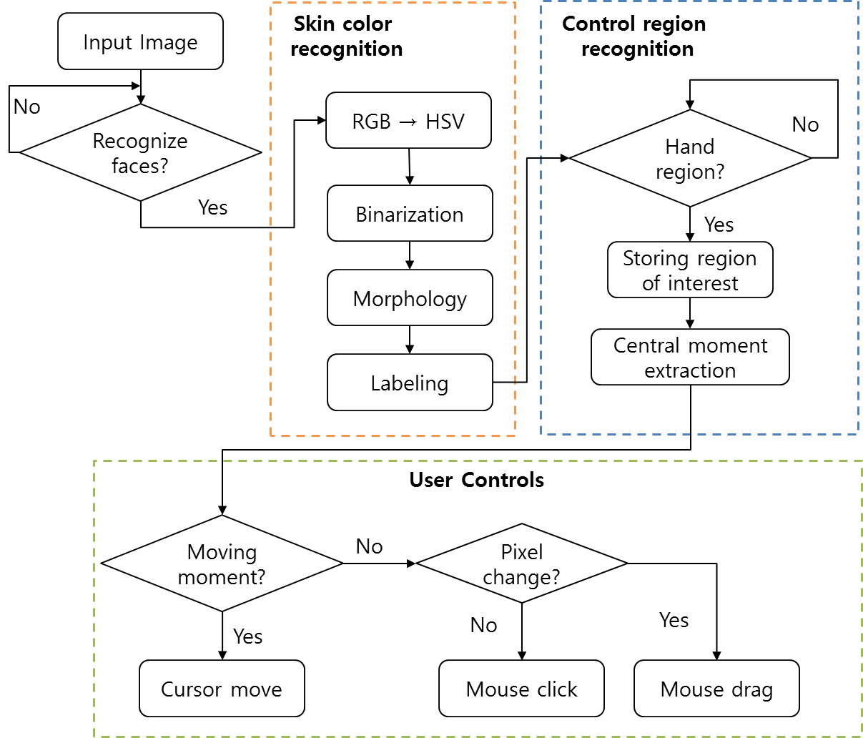
Figure 1. Real-time content control system through hand gestures

B. Face detection & Skin color recognition

Digital signage is so mainly used in environments with a large number of people, it is necessary to recognize only one person only for content control.
In this paper, we use OpenCV[3] that image processing library. System detects the features of the face only in a certain position. When face detection is completed, the system recognizes user.
After completion of the face detection, we have to search for the control region for content control. Skin color is the most efficient and simple way to distinguishing a person due to, it has accounted for a very narrow area [4]. In the proposed system, it recognizes a skin color region from the input image, and then the Morphology operations for removing a plurality of noise.

C. Control region recognition & User control

Previous research has often using complex calculation, and a variety of sensors for the control region recognized, and as a result there is a limit to the development and utilization costs. To solve these problems through the use that hand movements and gestures to control the process in the hands region close to the camera region aspect ratio, which is the most significant detect region. To solve this problem, it uses the hand region that closest to the camera and the most significant being the detection region. The system designates the region of interest that is satisfied with setting pixel information for certain time interval.
A simple user interface is needed to control the digital signage. The fingertips information is easy to control the content. But, when utilizing the fingertip information is problematic, because only hands should be detected in the input image. In this paper, we obtain the central moment for precise mouse events, and set the direction and distance of movement of the mouse pointer. Moment can be calculated using the Equation (1).

$m_{pq}=\sum_{x}{\sum_{y}{x^{p}y^{q}}}, \left(p,q=0,1,2,….\right)$ (1)
$$p,x :x coordinate, q,y :y coordinate$$

Central moment is calculated by a moment of synthesis information obtained by the Equation (1). Central moment is calculated by Equation (2).

$μ_{pq}= \sum_{x}{\sum_{y}{{\left(x-\overline{x}\right)}^{p}}{\left(y-\overline{y}\right)}^{q}}$ (2)
$\overline{x}= \frac{m_{10}}{m_{00}}$ , $\overline{y}= \frac{m_{01}}{m_{00}}$
It is compared to the central moment of the previous frame and the current frame, and moves the mouse pointer on the screen. Mouse events are used to click and drag. A certain period of time, if the coordinates of the mouse pointer does not exceed a certain range, function perform the click event. Drag event is operated in pixel value variation of the control region caused by the hand change. Equation (3) is an equation for the mouse event conversion.
$$F\left(x,y\right)=\frac{1}{6}\sum_{i=1}^{5}{I_{i}\left(x,y\right)}$$
(3)
$$G\left(x,y\right)=\left\{\begin{aligned}1, &if F\left(x,y\right)-F^{'}\left(x,y\right)=±100 \\ 0, &otherwise\end{aligned}\right.$$

III. Experiments

In this paper, we implement a user interface for digital signage control. And we experimented for performance evaluation. We confirmed the outdoor experiment results in different time zones. Figure 2 shows an experimental result in the afternoon time zone. The initial screen is composed of areas for user recognition and it detects the face in a certain position. Thereafter, the system detects the hand region from the skin-color image, and it designates a control region.

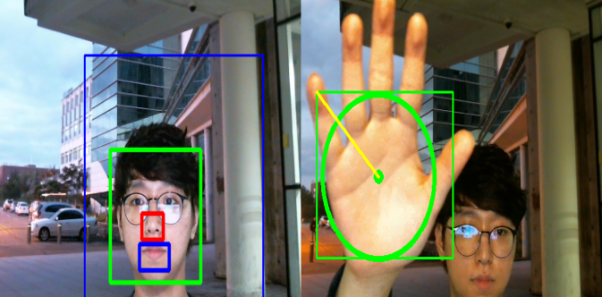
Figure 2. The experimental results of the afternoon

Figure 3 shows an experimental result in the night time zone. We confirmed that the face and the control region are quite well recognized. Since the image of the night less noise than the image of the afternoon, It was well aware of the face and the control region.

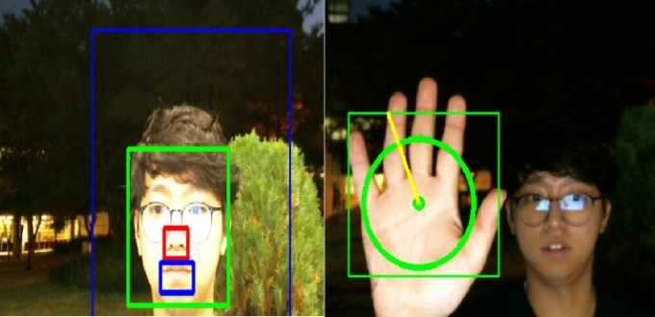
Figure 3. The experimental results of night time

IV. Conclusion

In this paper, we propose a system that recognizes face and hand motion in real-time image to control the contents of digital signage that advertising media. Previous research used a plurality of IR sensors or camera but we allows for real-time recognition using the size of the recognition region and skin color. It does not require to memorize various hand gestures to communicate or perform functions. As a result, anyone is expected to be easier to use the content. We expect to be able to build a user friendly interface to more efficiently.

References

[1] Syadus Sefat, Shahjahan, “A Hand Gesture Recognition Technique from Real Time Video,” International Conference on Electrical Engineering and Information Communication Technology (ICEEICT), pp. 1-4, 2015.
- Yunseong Lee, Woongsoo Na, Hyungchul Bae, Jeongseok Yu, Tajin Kim, Juho Lee, Zeynep Vatandas, Junho Park, Jongha Yoon and Sungrae Cho, “Resect Advance in Digital Signage,” Proceedings of Symposium of the Korean Institute of communications and Information Sciences, pp. 625-626, January, 2014.
- OpenCV : http://opencv.org/
- Ching-Tang Hsieh, Cheng-Hsiang Yeh, Kuo-Ming Hung, Li-Ming Chen, Chin-Yen Ke, “A Real Time Hand Gesture Recognition System Based on DFT and SVM,” International Conference on Information Science and Digital Content Technology (ICIDT), Vol. 3, pp. 490-494, 2012.

